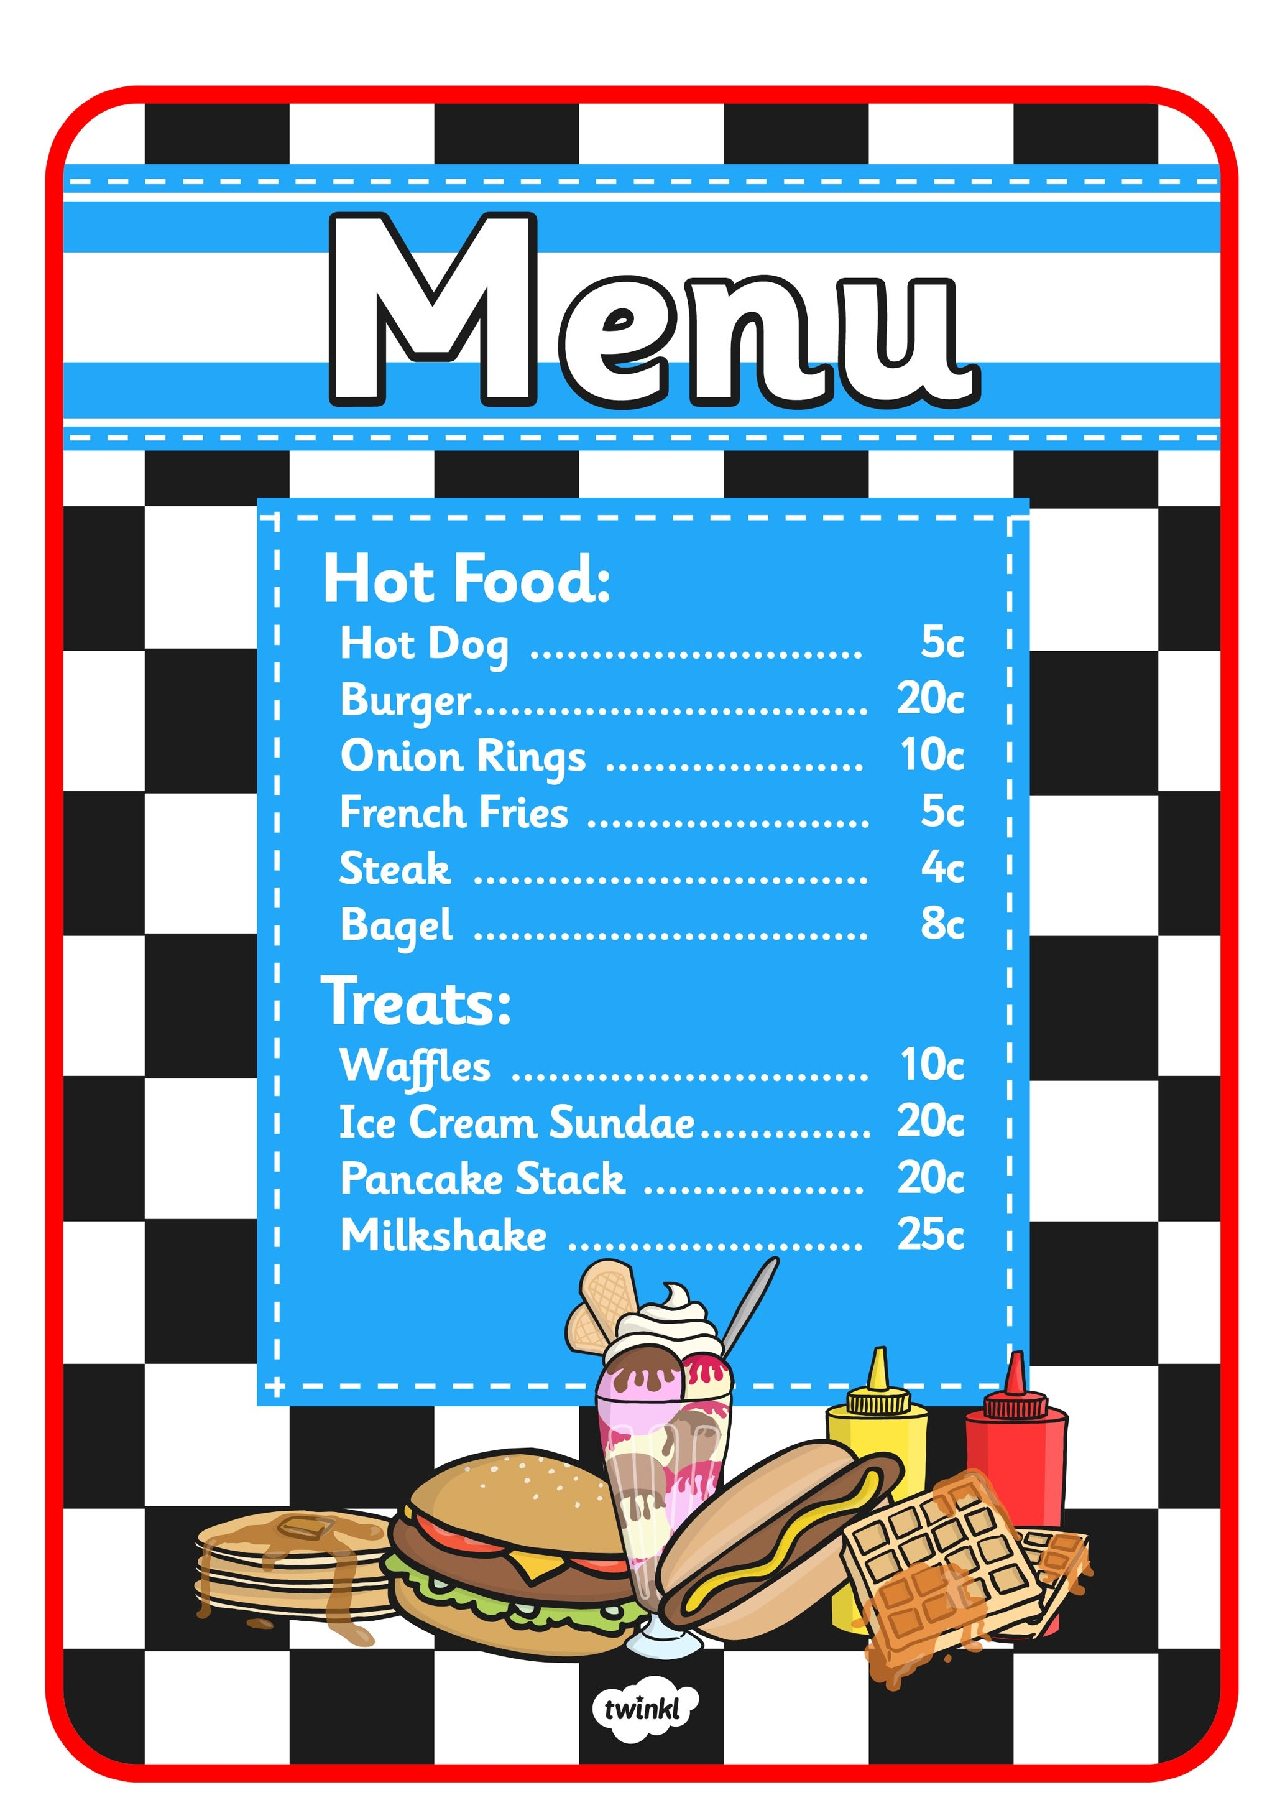

**March 2023**

**Friday 3rd**

Lasagne & Salad

**Friday 10th**

Chicken Pasta

**Friday 17th**

Irish Stew

**Friday 24th**

Chilli Con Carne & Rice

**Friday 31st**

Vegetable Soup