Bluebelles

West Kirby Concourse Leisure Centre

Grange Road, West Kirby, CH48 4HX

W: [www.wirralevolutions.org](http://www.wirralevolutions.org) Facebook.com/bluebellestearooms



**Best Bites Café**





**Bluebelles**

**Breakfast**

Served All Day

**Full English £7.15**

1 Egg, 2 bacon, sausage, hash brown,

mushrooms, grilled tomato, baked

beans, black pudding & toast with butter

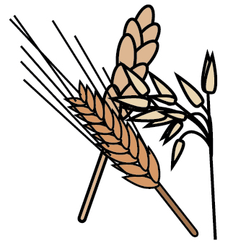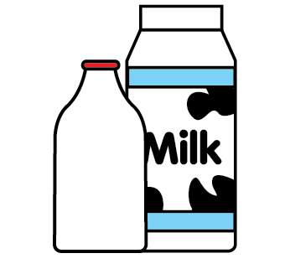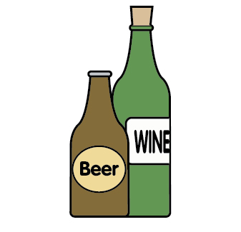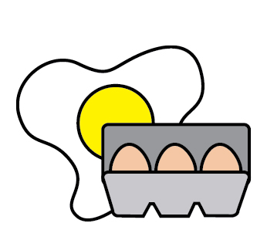

**Vegetarian Breakfast £7.15**

1 Egg, vegetarian sausage, halloumi,

hash brown, mushrooms, grilled tomato,

baked beans & toast with butter



**Breakfast Sandwiches**

Served on white or brown bread or toast,

 **Egg x 2 £3.30**

 **Bacon** **£3.57**

 **Bacon & Egg £3.75**

**Sausage & Egg £3.75**

 **Bacon & Sausage £4.12**

**Open Breakfast Sandwich**    **£4.67**

Bacon, sausage & Fried Egg

**Hollywood Brunch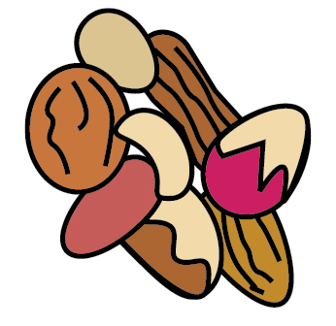£5.77**

Guacamole, scrambled egg, tomato, lettuce leaf with crispy bacon, towered in a brioche bun.

Served with a salad garnish

**Teacake** **£2.50**

**Toast x2** **£1.30**

**Please check our in-house specials board for more choices with allergens**

**Drinks** with milk

Regular Large

**Coffee**

Americano **£2.20 £2.75**

Cappuccino **£2.75 £3.24**

Latte **£2.75 £3.24**

Flavoured Coffee/extra **£0.55 £0.55**

**Tea**

English Breakfast **£1.65**

Earl Grey **£1.92**

Peppermint **£1.92**

Green Tea **£1.92**

Fruit or Herbal **£1.92**

**Hot Chocolate £2.20 £2.75**

**Special Hot Chocolate £2.75 £3.24**

Cream & Marshmallows

**Cold Drinks**

Coke/Sprite/Fanta **£1.43**

Spring Still Water **£1.32**

Spring Sparkling Water **£1.32**

Fruit Shoot **£1.32**

**Milkshakes**

Strawberry **£1.60**

Chocolate **£1.60**

Banana **£1.60**

**Best Bites** offers a unique service for adults with disabilities as part of **Wirral Evolutions**. We promote independent living skills, knowledge and help to achieve nationally recognised qualifications within a real work environment. Our aim is to help people to gain employment or go on to further training/education. Most importantly we aim to develop individuals and improve independence to help people we support lead a reach and fulfilling life and increase their contribution to the community.

|  |  |  |  |  |  |  |  |  |  |  |  |
| --- | --- | --- | --- | --- | --- | --- | --- | --- | --- | --- | --- |
| **Celery** | **Cereals**  **Containing**  **Gluten** | **Crustaceans** | **Eggs** | **Fish** | **Sesame seeds** | **Lupin** | **Milk** | **Mustard** | **Nuts Peanuts** | **Sulphur**  **Dioxide** | **Soya** |

**Light Bites**



**Welsh Rarebit 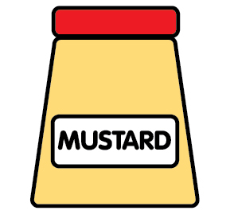 £4.95**

Served with side salad & pickle

**Posh Cheese & Bacon Toastie** **£5.44**

Grilled bacon, Brie & cranberry toasted

On your choice of white or brown bloomer

**Chicken Strips 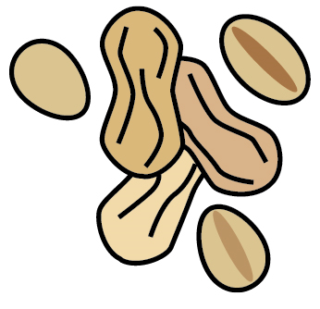£5.44**

Crispy chicken tenders served with a

side salad

**Fish Finger Sandwich** **£6.54**

Jumbo cod fish fingers served on bloomer

bread with mushy peas, Chips &

tartar sauce

**Salad Choices**   

Freshly prepared salad, served with house coleslaw, half a boiled egg & bread of choice.

**Chicken £5.44**

**Ham £5.44**

**Prawn £5.80**

**Soup £3.85**

Homemade Soup of the Day made with

seasonal ingredients served with bread & butter

**Side Dishes**

**Chips £2.75**

**Kids Menu**

All served with, chips, beans or salad & carton drink

**£4.00**

Sauage x1

Fish Finger x1

Egg x1

**Sandwich Boxes £3.50**

Ham

Cheese

Egg

All served with crisps, carton drink, snack

**Sandwiches & Wraps**

All sandwiches are available on white or brown bloomer bread and are served with side salad and crisps

**Cheese, Tomato & Pickle** **£4.95**

Cheddar cheese served with pickle

**BLT** **£5.44**

A classic combination of bacon, lettuce

& tomato, Mayo

**Coronation Chicken** **£5.44**

Homemade Coronation Chicken & salad

**Ham Salad**  **£5.44**

Home cooked gammon & salad

**Eggs & Cress** **£5.44**

Free range egg, mayo & watercress

**Prawn & Marie Rose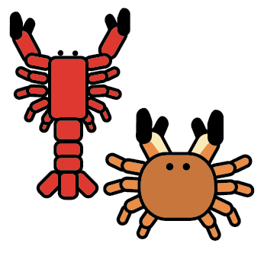 £5.80**

Served with salad

**Paninis**

All served with side salad and crisps

**Ham & Cheese 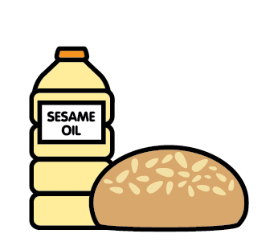 £5.77**

**Mozzarella & Tomato** **£5.77**

**Tuna Melt** **£6.30**

**Goats Cheese & Red Onion Chutney****£6.30**

**Chicken, Mozzarella & Tomato Chutney****£6.30**

**Jacket Potatoes**

Oven baked and served with a side salad, coleslaw, and your choice of filling

**Coronation Chicken**  **£5.44**

**Tuna & Sweetcorn Mayo** **£5.44**

**Cheese, Onion, Tomato & Mayo** **£5.44**

**Prawn & Marie Rose**  **£5.80**

**Cheese & Beans** **£4.95**

**We offer a selection of homemade cakes, patisseries & deserts from £3.00 - £3.50**

***Please see our display for choices***