Wirral Council’s Budget 2021-22
What do you think?

1

Introduction
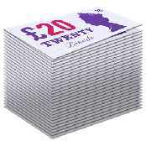Every year, Wirral Council agrees a budget.

This is where we work out how much money is going to come in and how we should spend it.

The coming year is going to be very difficult. We expect to receive less money.

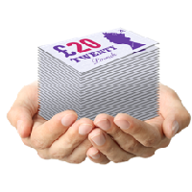
We have to think about ways to:
•
save money by reducing the amount we spend on certain services.
•

raise money by charging people for certain things.

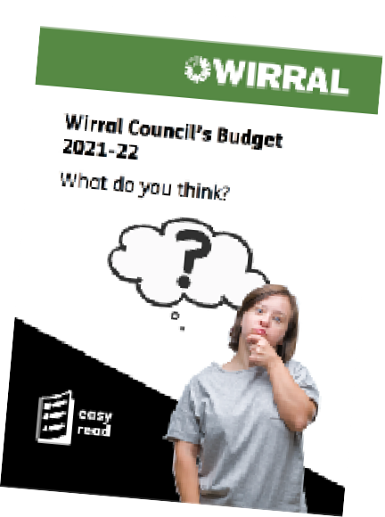Before we make any decisions, we want to know what you think.

Please tell us what you think by answering the questions in this survey.

Services for children and young people

Services for children and young people have improved in Wirral since 2016.

This is because of the hard work of the people who work in the service.

It is also because we have spent money on making the services better.

The youth service
The youth service can help young people do better at school.

It can help to keep young people safe from:
•
harm

criminals who want them to do things that are against the law
•

taking part in anti-social behaviour.
•
Anti-social behaviour means being too noisy and disturbing or frightening other people.

We are looking at reducing the money to the youth service to save £200,000.
£200,000

Question 1: Do you agree or disagree with reducing the money to the youth service to save £200,000?

Strongly agree Agree

Neither agree nor disagree Disagree

Strongly disagree

Children’s services
Children’s services help to protect children who are being harmed and abused. They also help families to keep their children safe.

We are looking at reducing the money to children’s services to save
£102,000
£102,000.

Question 2: Do you agree or disagree with reducing the money to children’s services to save £102,000?

Strongly agree Agree

Neither agree nor disagree Disagree

Strongly disagree

The environment, climate emergency and transport
The environment is the world around us. It includes the air we breathe and all living things.

The climate emergency is the dangerous changes in weather around the world, like worse storms and flooding. It is caused by too much pollution going into the air.

The Council is working to:
•
help people to walk and cycle
•

recycle more of their waste - this means turning waste into something that can used again
•

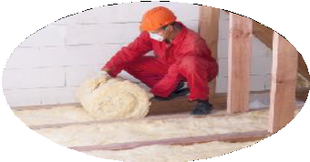make changes to buildings so they keep people warm while saving money
•

plant more wildflowers on grassy areas in Wirral.

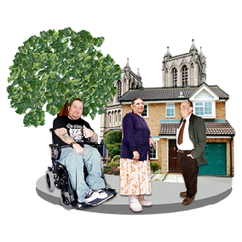Neighbourhood services
£350,000
Neighbourhood services look after each local area in Wirral.

We want neighbourhood services to work in a better way. This will save
£350,000.

Question 3: Do you agree or disagree with changing how neighbourhood services work so we save £350,000?

Strongly agree Agree

Neither agree nor disagree Disagree

Strongly disagree

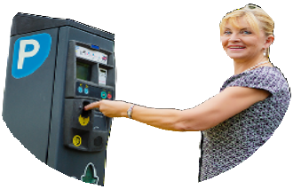
Parking charges
Parking charges help to control the amount that people use their cars.

Cars are one of the main causes of pollution. It is better if people can use public transport or walk or cycle.

We are looking at options to increase parking charges which could raise an extra £1 million.
£1million

Question 4: Do you agree or disagree that we should look at increasing parking charges?

Strongly agree Agree

Neither agree nor disagree Disagree

Strongly disagree

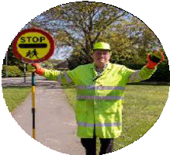The school crossing patrol service
£276,300
We don’t have to provide a school crossing patrol service by law.

If we stopped this service, it would save £276,300.

Question 5: Do you agree or disagree with stopping the school crossing patrol service?

Strongly agree Agree

Neither agree nor disagree Disagree

Strongly disagree

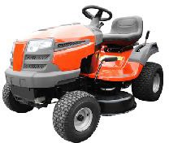
Cutting the grass
We are thinking about reducing the number of times that we cut the grass on green areas.
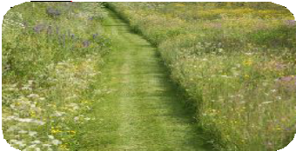
We are thinking of:
•
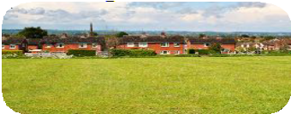
only cutting the edges of large grassy areas, so that wildflowers can grow in the middle
•

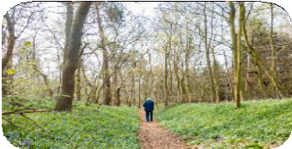cutting the grass less often in parks and open spaces
£250,000
•

letting woodland areas go wild, so they are good for wildlife.

This would save us £250,000.

Question 6: Do you agree or disagree with these ideas?

Strongly agree Agree

Neither agree nor disagree Disagree

Strongly disagree

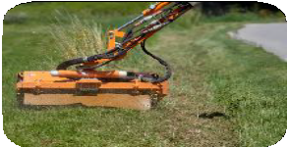Grass verges
We are thinking we might stop cutting the grass and picking up litter on 45 green spaces and 85 grass verges.

Instead we might plant trees, leave the areas to go wild or create allotments.

Allotments are pieces of land that people rent to grow vegetables and plants.
£100,000

This would save us £100,000.

Question 7: Do you agree or disagree with this idea?

Strongly agree Agree

Neither agree nor disagree Disagree

Strongly disagree

Public toilets
We are thinking of closing our 9 public toilets.
These are at:
Harrison Drive, New Brighton Moreton Common
•
Moreton Cross
•
West Kirby Marine Lake
West Kirby Concourse (outside), Parade Gardens Hoylake
•
Meols Parade
£142,000
•
New Ferry
- Thornton Hough.
This would save us £142,000.
Question 8: Do you agree or disagree with this idea?

Strongly agree Agree

Neither agree nor disagree Disagree

Strongly disagree

Emptying bins
We are thinking of:
•
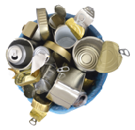emptying green bins every 3 weeks instead of every 2 weeks

letting you put more things in the grey recycling bin
£180,000
•

setting up a separate food waste collection.
•

This would save us £180,000.

Question 9: Do you agree or disagree with this idea?

Strongly agree Agree

Neither agree nor disagree Disagree

Strongly disagree

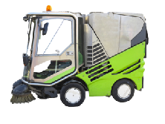Street cleaning and collecting waste
We think that street cleaning and collecting waste could be done in another way that saves money.
£75,000

We think we could save £75,000.

Question 10: Do you agree or disagree with this idea?

Strongly agree Agree

Neither agree nor disagree Disagree

Strongly disagree

Anti-social behaviour and environmental crime
Anti-social behaviour means being too noisy and disturbing or frightening other people.

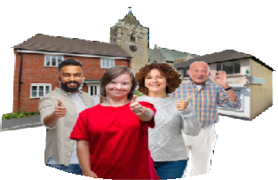
Environmental crime is when people damage trees and bushes, or dump waste where they shouldn’t.

We want to work with local communities to stop all of this bad behaviour.

We think that this would lead to an extra saving of £150,000.
£150,000

Question 11: Do you agree or disagree with this idea?

Strongly agree Agree

Neither agree nor disagree Disagree

Strongly disagree

Tourism, culture and leisure
Culture includes theatre, arts and music.
£620,000

Tourism and culture bring money into Wirral.

We have been helping businesses that do this type of work.

We are thinking of reducing the amount we spend to help these businesses.

We think that this would save
£620,000.

Question 12: Do you agree or disagree with this idea?

Strongly agree Agree

Neither agree nor disagree Disagree

Strongly disagree

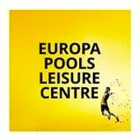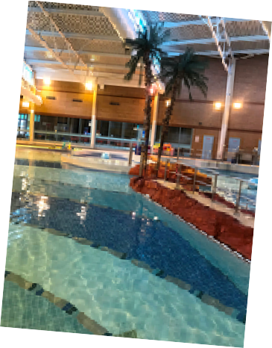Europa Pools

We are thinking of closing Europa Pools in Birkenhead.

This would save £620,000.
£620,000

Question 13: Do you agree or disagree with this idea?

Strongly agree Agree

Neither agree nor disagree Disagree

Strongly disagree

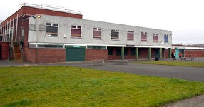Woodchurch Leisure Centre
£322,000
Woodchurch Leisure Centre is closed because of COVID-19 and because of making some improvements to the building.

COVID-19 is a new illness that is spreading around the world. It can affect your lungs and breathing.

We are thinking of delaying the reopening of this centre.

This could save us £322,000.

Question 14: Do you agree or disagree with this idea?

Strongly agree Agree

Neither agree nor disagree Disagree

Strongly disagree

Golf courses
Wirral Council runs 4 golf courses.

Some private companies would like to run these golf courses for us.

We are thinking of looking at the options.

Closing the golf courses, or letting private companies run them, could save us £273,000.
£273,000

Question 15: Do you agree or disagree with this idea?

Strongly agree Agree

Neither agree nor disagree Disagree

Strongly disagree

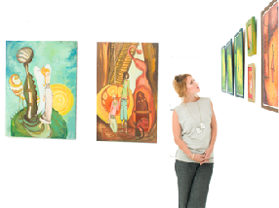Museums
We are looking at closing the museums. This would include the Williamson Art Gallery and Museum.

Closing the museums could save
£327,500
£327,500 every year.

Question 16: Do you agree or disagree with this idea?

Strongly agree Agree

Neither agree nor disagree Disagree

Strongly disagree

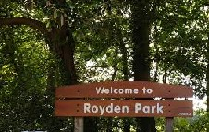Royden Park
We are looking at ways to make more money from Royden Park.

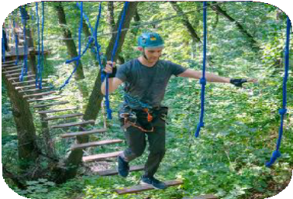
We are looking at making a high ropes aerial park near the new car park.

A high ropes aerial park is where you walk and climb across a rope course that is high up in the trees.
£80,000

We think we could raise £80,000 from this idea.

Question 17: Do you agree or disagree with this idea?

Strongly agree Agree

Neither agree nor disagree Disagree

Strongly disagree

Supporting local businesses

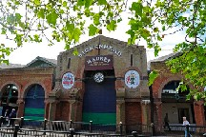Birkenhead Market
£240,000
We are looking at improving the Birkenhead Market building.

We are also thinking about reducing the number of staff.

The market may have to move to a different place while the work is being done.

We think that this will save us
£240,000.

Question 18: Do you agree or disagree with this idea?

Strongly agree Agree

Neither agree nor disagree Disagree

Strongly disagree

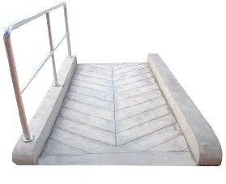Making council buildings accessible for disabled people
For several years we have put aside a separate amount of money to make council buildings accessible for disabled people.

This work has now been done and we don’t need to put money aside for this anymore.
£200,000

This would save us £200,000.

Question 19: Do you agree or disagree with this idea?

Strongly agree Agree

Neither agree nor disagree Disagree

Strongly disagree

Housing

Community Alarm Service
The housing department’s Community Alarm service means that health and social care services don’t have to provide this service.

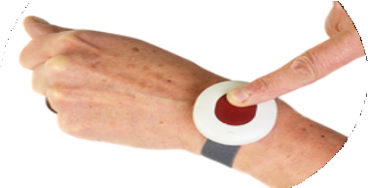
Community Alarm is a way for a vulnerable person to call for help by pressing a button which they keep on them at all times.

We are thinking of stopping this service. We think this will save us
£500,000
£500,000.

Question 20: Do you agree or disagree with this idea?

Strongly agree Agree

Neither agree nor disagree Disagree

Strongly disagree

Adult Social Care

Day services for people with a learning disability
We are looking at bringing the day services for people with a learning disability up-to-date.
We are looking at better ways to provide this service.
£500,000

We think that we could save
£500,000.

Question 21: Do you agree or disagree with this idea?

Strongly agree Agree

Neither agree nor disagree Disagree

Strongly disagree

Council offices
We are looking at making some changes to the office work at the Council.

This might include:
•
changing the way we support staff to use computers

changing how we print information
•

reducing the number of staff that support our managers
•

changing the way we get other organisations to do work for us.
•

We think that we could save £2 million to £3 million.

£2 - 3million

Question 22: Do you agree or disagree with this idea?

Strongly agree Agree

Neither agree nor disagree Disagree

Strongly disagree

Hardship fund
£3.9million
We received £3.9 million from the Government to help local people who are having difficulties because of COVID-19.

We have used this to reduce the local Council Tax of people who are having difficulties.

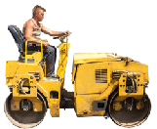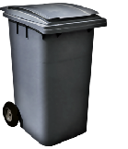Council Tax is money that people pay the council for things like collecting rubbish and fixing the roads.
£1.5million

By the end of August we had used
£1.5 million.

If there is any of this money left in March, we are thinking of using it to cancel the Council Tax for people who have not been able to pay for a very long time.

This would mean that we would have about £1 million to use towards council services.
£1million

Question 23: Do you agree or disagree with this idea?

Strongly agree Agree

Neither agree nor disagree Disagree

Strongly disagree

Local ward budgets
£250,000
Each Councillor has a certain amount of money they can spend locally in their ward.
Councillors are people who have been chosen to run the Council.
A ward is a very local area.
Councillors usually give this money to local community organisations or charities, or to make some improvement to the local area.
We are thinking of stopping this. Stopping this money would save
£250,000.
Question 24: Do you agree or disagree with this idea?

Strongly agree Agree

Neither agree nor disagree Disagree

Strongly disagree

Question 25

Any other ideas?
If you have any other ideas for ways we could save money or earn money, please let us know.

Thank you

Thank you for your answers. Please now send this survey back to us by email to:

BudgetConsult@wirral.gov.uk

For more information
For more information please contact us by phone: 0151 606 2000

Easy Read by easy-read-online.co.uk

